-----------------------1-------------

SELECT stud.name, stud.surname, h.hobby_name FROM student stud

INNER JOIN student_hobby sh ON stud.n_z = sh.id

INNER JOIN hobby h ON h.id = sh.id

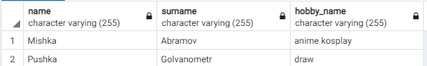

---------------------2-------------------

SELECT (NOW ()-sh.started_at) as doing, *

FROM student stud

INNER JOIN student_hobby sh ON stud.n_z = sh.student_id

INNER JOIN hobby h ON h.id = sh.hobby_id

WHERE sh.finished_at IS NULL

ORDER BY sh.started_at

LIMIT 1



Там ещё много столбцов после

--------------------3---------------

SELECT stud.name, stud.surname, stud.n_z, stud.age

FROM student stud LEFT JOIN (

SELECT student_id, SUM(risk) FROM student_hobby sh

JOIN hobby h on sh.hobby_id = h.id

GROUP BY student_id) as nt

ON stud.id=nt.student_id

WHERE stud.score>= (select AVG(score) FROM student) and nt.sum>9

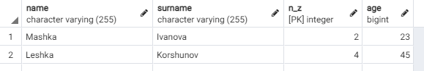

---------------------------4----------------

SELECT stud.surname, stud.name, stud.n_z, stud.age

FROM student stud;

SELECT h.hobby_name

FROM hobby h

SELECT 12 * extract(year from (sh.finished_at, sh.started_at)) as doing

FROM student_hobby sh

INNER JOIN sh ON stud.n_z = sh.student_id

INNER JOIN hobby h ON h.id = sh.hobby_id

WHERE sh.finished_at IS NOT NULL

------------------------5------------------

SELECT stud.surname, stud.name, stud.n_z, stud.age

FROM student stud

Inner JOIN (

SELECT student_id, (count(sh.started_at)-count(sh.finished_at)) as counter

FROM student_hobby sh

JOIN hobby h on sh.hobby_id = h.id

GROUP BY student_id) as nt

ON stud.n_z=nt.student_id

WHERE stud.age>19 and nt.counter>1

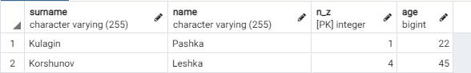

-----------------6-------------

SELECT stud.n_group, AVG(stud.score)

FROM student stud

INNER JOIN student_hobby sh on stud.n_z=sh.student_id

WHERE sh.finished_at IS NULL and sh.started_at IS NOT NULL

GROUP BY stud.n_group

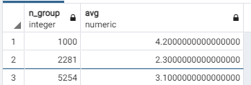

--------------------7-------------

SELECT h.hobby_name as hobby, h.risk, 12*extract( days from (NOW ()-sh.started_at)) as doing, stud.n_z

FROM student stud

INNER JOIN student_hobby sh ON stud.n_z = sh.student_id

INNER JOIN hobby h ON h.id = sh.hobby_id

WHERE sh.finished_at IS NULL and stud.n_z=1

ORDER BY sh.started_at

У меня выдало 2 строки, но можно и прописать limit 1

------------------8----------------

SELECT h.hobby_name as hobby

FROM hobby h

INNER JOIN student_hobby sh on h.id=sh.hobby_id

INNER JOIN( SELECT stud.n_z FROM student stud

WHERE stud.score=(select MAX(score) from student)) as nt on nt.n_z = sh.student_id

WHERE sh.finished_at IS NULL



Вроде работает, а вроде и нет

Мне кажется просто не сраслось по студентам и хобби

----------------9-------------

SELECT h.hobby_name as hobby

FROM hobby h

INNER JOIN

student_hobby sh on h.id = sh.hobby_id

INNER JOIN (SELECT stud.n_z

FROM student stud

WHERE stud.score=3 and n_group/1000=2) stud on stud.n_z=sh.student_id

WHERE sh.finished_at IS NULL

В теории должно работать, потому что я у одногруппника проверял

Ну на его данных, но у меня просто нет троечников на 2 курсе

Вывод: второкурсники-умные

Ну вот что получилось просто у второкурсников

SELECT h.hobby_name as hobby

FROM hobby h

INNER JOIN

student_hobby sh on h.id = sh.hobby_id

INNER JOIN (SELECT stud.n_z

FROM student stud

WHERE stud.score<6 and n_group/1000=2) stud on stud.n_z=sh.student_id

WHERE sh.finished_at IS NULL

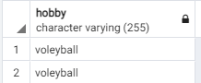

-----------------------10----------------

Взял этот запрос у Паши, но он мне его на паре объяснил

SELECT course_act.course

FROM

(SELECT course, COUNT(DISTINCT sh.student_id )as zanim

FROM student_hobby sh

INNER JOIN (

SELECT DISTINCT n_group/1000 as course, st.n_z

FROM student st) as nt on nt.n_z = sh.student_id

WHERE finished_at IS NULL

GROUP BY course) as course_act

RIGHT JOIN

(SELECT n_group/1000 as course, COUNT(*) from student st GROUP BY n_group/1000) as course_all

on course_act.course = course_all.course

WHERE course_act.zanim*1./course_all.count>0.5



-----------------------11--------------

SELECT n_group FROM student

GROUP BY n_group

HAVING COUNT(CASE

WHEN score>=4 THEN 1

ELSE NULL END)/COUNT(*)>=0.6

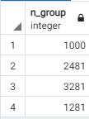

--------------12-------------

SELECT n_group/1000 as course, COUNT(DISTINCT h.hobby_name)

FROM student as stud

RIGHT JOIN student_hobby as sh on sh.student_id=stud.n_z

Left JOIN hobby as h on h.id=sh.hobby_id

GROUP BY n_group/1000

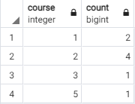

-----------------13---------------

SELECT stud.n_z, stud.surname, stud.name, stud.age, n_group/1000 as course

FROM student as stud

LEFT JOIN student_hobby as sh on sh.student_id=stud.n_z

Left JOIN hobby as h on h.id=sh.hobby_id

WHERE sh.hobby_id is NULL and score=5

ORDER BY course, stud.age DESC



Ну не оказалось таких, ну бывает

--------------14--------------

CREATE OR REPLACE VIEW full_info AS

SELECT distinct stud.n_z, stud.name, stud.surname,stud.adress,stud.score,stud.n_group,stud.age

FROM student stud

RIGHT JOIN student_hobby sh on stud.n_z=sh.student_id

WHERE finished_at is null and extract(year from (clock_timestamp ( )-sh.started_at))>5



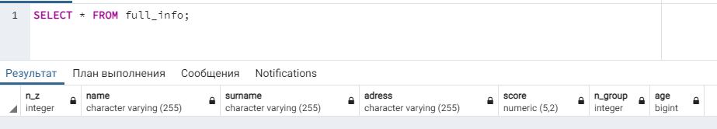

Никого у меня нет, кто дольше 5 лет занимается

А это без условия на 5 лет

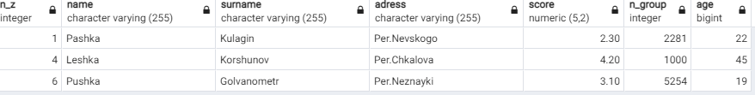

-----------------------15--------------

SELECT h.hobby_name, COUNT((sh.student_id, sh.hobby_id)) as count

FROM hobby h LEFT JOIN student_hobby sh on h.id=sh.hobby_id

WHERE sh.finished_at is null

GROUP BY h.hobby_name

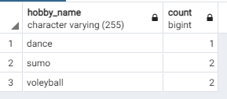

У меня всего 5 null у finished_at, поэтому всё ок

--------------16------------------

SELECT id FROM(

SELECT h.id, COUNT((sh.student_id, sh.hobby_id))

FROM hobby h LEFT JOIN student_hobby sh on h.id=sh.hobby_id

WHERE sh.finished_at is null

GROUP BY h.id

ORDER BY count desc limit 1) as popular_hobby



-----------17------------

SELECT * FROM student stud RIGHT JOIN (

Select student_id from student_hobby sh

RIGHT JOIN( SELECT h.id FROM hobby h LEFT JOIN student_hobby sh on h.id=sh.hobby_id

WHERE sh.finished_at is null

GROUP BY h.id

ORDER BY COUNT(distinct (sh.student_id, sh.hobby_id)) desc limit 1) as besth on besth.id=sh.hobby_id

WHERE finished_at is null) as stid on stud.n_z = stid.student_id



И ещё колонка со student_id =6

--------------18--------------

SELECT id FROM hobby ORDER BY risk desc limit 3

Мне страшно, что такой маленький запрос получился

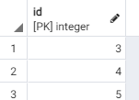

---------------------19-------------------

SELECT distinct stud.n_z, stud.name, stud.surname,stud.n_group sh.started_at FROM

student stud RIGHT JOIN student_hobby sh on stud.n_z=sh.student_id

WHERE sh.finished_at is null

ORDER BY sh.started_at limit 5

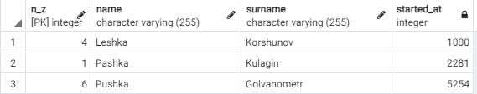

О, там даже я есть(самый первый)

-------------------20----------------

SELECT distinct n_group from

(SELECT distinct stud.n_z, stud.name, stud.surname,stud.n_group, sh.started_at FROM

student stud RIGHT JOIN student_hobby sh on stud.n_z=sh.student_id

WHERE sh.finished_at is null

ORDER BY sh.started_at limit 5 ) as groupsss

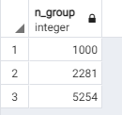

----------21-----------------

CREATE OR REPLACE VIEW not_full_info AS

SELECT n_z, name, surname

FROM student

ORDER BY score desc





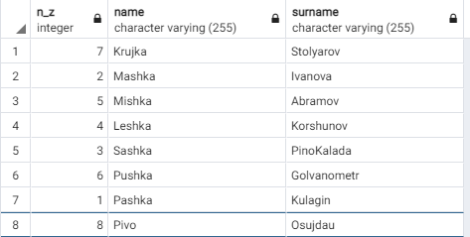

-----------------22-----------

Фиг знает как сделать, что-то пробовал но ничего не получилось

----------------23-----------

Тоже самое

-----------------24-------------

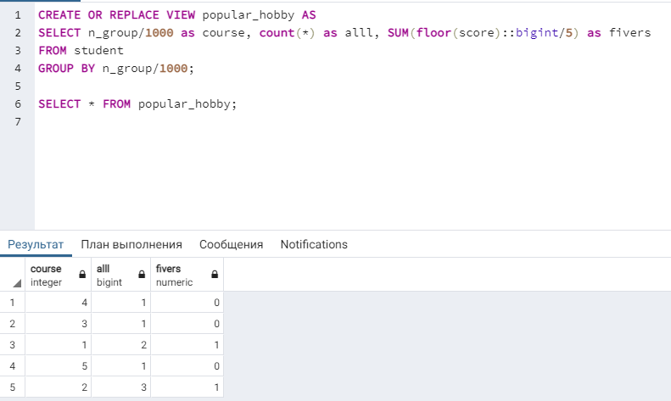

--------------------25----------------------

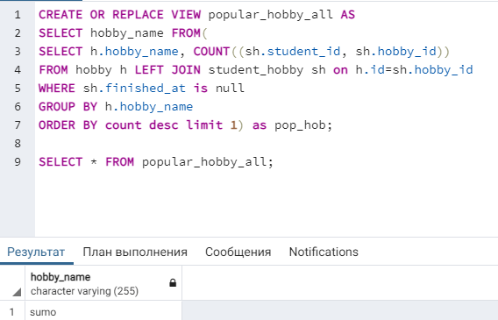

Ахахахахаха

------------------26---------------------

CREATE VIEW updatable as

SELECT * FROM hobby;

SELECT * FROM updatable;

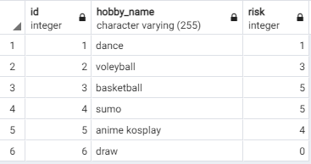

В таких представлениях мы можем изменить или удалить строки или добавить в них новые строки.

-----------27-----------------

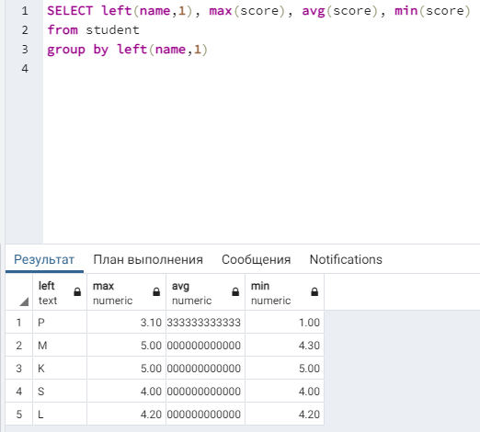

И добавить HAVING max(score)>3.6

Тогда улетят Pashka, Pushka и Pivo(без буквы P)

----------28----------------

SELECT n_group/1000 as course, surname, max(score),min(score)

from student

group by n_group/1000, surname

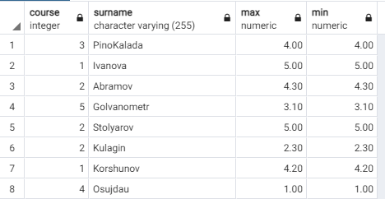

-------------29-------------

SELECT age, COUNT(distinct hobby_id)

FROM student stud RIGHT JOIN student_hobby sh on stud.n_z = sh.student_id

GROUP BY age

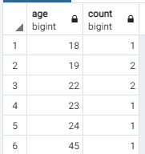

-----------------30---------------

SELECT left(stud_tabl.name,1), min(risk), max(risk)

FROM (student stud RIGHT JOIN student_hobby sh on stud.n_z = sh.student_id) as stud_tabl

LEFT JOIN hobby h on h.id=stud_tabl.student_id

GROUP BY left(stud_tabl.name,1)

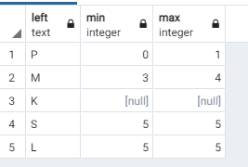

---------------31---------------

Тут Паша сказал создать колонку с годом рождения, ну я послушался и создал

Через след запросы

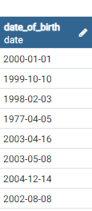

ALTER TABLE student

ADD date_of_birth DATE;

Потом добавим ограничения

ALTER TABLE student

ALTER COLUMN date_of_birth

SET NOT NULL;

SELECT extract(month from date_of_birth) as month, avg(score)

FROM (student stud right join student_hobby sh on sh.student_id=stud.n_z) as month_table left join hobby h on h.id=month_table.hobby_id

WHERE finished_at is null and h.hobby_name='dance'

GROUP BY month



-------------32------------

SELECT distinct 'Имя: '||stud.name||', фамилия: '||stud.surname||', группа: '||stud.n_group #эта всё одна строчка

FROM student stud RIGHT JOIN student_hobby sh on stud.n_z=sh.student_id

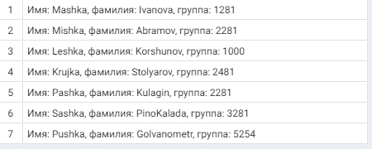

-------------------33--------------

SELECT case position('ов' in surname)::varchar

when '0' then 'не найдено'

else position('ов' in surname)::varchar end

FROM student

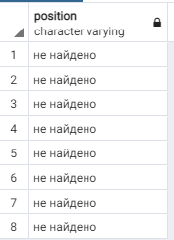

-------------------34----------------

SELECT case

when (length(surname)>10) then surname

else rpad(surname,10,'#') end

FROM student

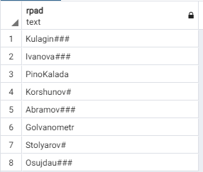

---------35----------------

SELECT rtrim(surname,'#')

FROM( SELECT case

when (length(surname)>10) then surname

else rpad(surname,10,'#')

end as surname

from student) as norm_tabl

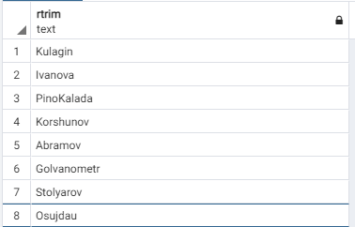

------------36------------

SELECT extract(days FROM date_trunc('month', '4-1-2018'::date) + interval '1 month - 1 day');

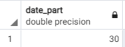

С февралём всё тоже работает

SELECT extract(days FROM date_trunc('month', '2-1-2020'::date) + interval '1 month - 1 day');



SELECT extract(days FROM date_trunc('month', '2-1-2018'::date) + interval '1 month - 1 day');



-----------37-----------

Нашёл 2 способа на stackoverflow пришлось их чуток переделать

SELECT current_date + cast(abs(extract(dow FROM current_date) - 7) - 1 AS int);

SELECT current_date+7 - (( cast(extract(dow FROM current_date) AS int)+1) %8)



---------38--------------

Select

extract(century from current_date) as century,

extract(weeks from current_date) as weeknumber,

extract(days from current_date) as daynumber; 

---------39-------------

SELECT stud.name, stud.surname, h.hobby_name,

case

when (sh.finished_at is null) then 'Закончил'

else 'Занимается' end

FROM student stud RIGHT JOIN student_hobby sh on stud.n_z=sh.student_id LEFT JOIN hobby h on h.id = sh.hobby_id

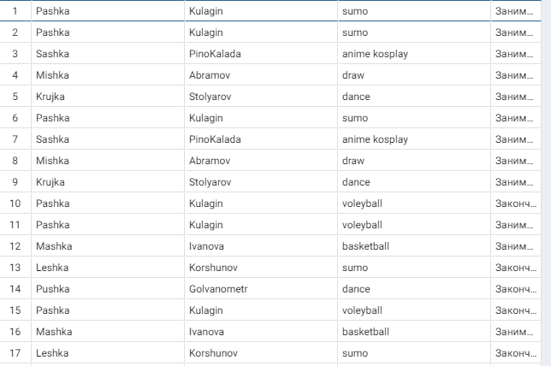

Наконец-то привычные запросы

А то прошлые с датами мне не понравились

---------------------ураааа последний---------------

SELECT n_group,

count(case round(score) when 2 then 1 end) as "2",

count(case round(score) when 3 then 1 end) as "3",

count(case round(score) when 4 then 1 end) as "4",

count(case round(score) when 5 then 1 end) as "5"

from student

group by n_group

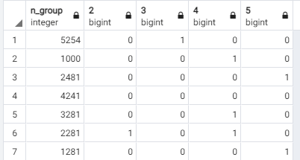

Всё

В целом то, что было непонятно я спросил у Паши с Костей, а так нужно всё на практике фигачить